LRA New CG James Dorbor Jallah Takes Over
Outlines His Vision for A ‘New’ LRA

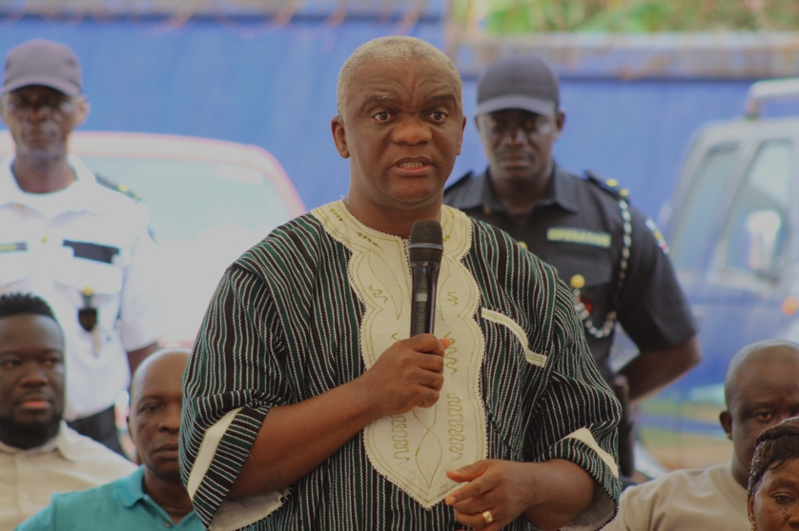
Monrovia, Liberia - March 1, 2024 - The Liberia Revenue Authority (LRA) welcomed its new Commissioner General, James Dorbor Jallah, who officially assumed leadership of the Tax Authority on Friday, March 1. Commissioner General Jallah outlined his ambitious vision for reform and progress in revenue collection, emphasizing the pursuit of autonomy for the LRA.
LRA new Commissioner General, James Dorbor Jallah speaking to employees when he took over Friday morning

In his inaugural address, Commissioner General Jallah underscored the vital role of revenue collection in national growth and development, calling for the unwavering commitment of all LRA staff. He assured employees, taxpayers, the business community, and stakeholders with a vision of a revitalized LRA characterized by professionalism, integrity, and prioritization of staff welfare and development.

Acknowledging the commendable efforts of LRA employees in surpassing challenges to elevate domestic revenue to US$600 million, Commissioner General Jallah set an even loftier goal of surpassing the US$1 billion milestone. He emphasized the pivotal role of the LRA in advancing the government's development agenda, stressing the government's dependence on collected revenue for success.

To achieve ambitious revenue targets, Commissioner General Jallah urged staff to maintain unwavering integrity in their duties. He announced plans to enhance existing whistleblowing programs to enhance transparency and integrity within the LRA.

Commissioner General Jallah outlined his objective of securing full autonomy for the LRA within his first year, envisioning it as a strategy to bolster performance and efforts to exceed the billion-dollar revenue goal. He emphasized that autonomy would facilitate strategic investment in technology, enabling automation and providing staff with the necessary resources to fulfill their duties effectively.

Additionally, Commissioner General Jallah called upon the business community to adhere strictly to tax and business laws, advocating for transparent compliance with payment processes and procedures. He assured compliant businesses of smooth operations and success within the business environment.

Expressing unwavering dedication to collaboration with the business community, government officials, and the public, Commissioner General Jallah pledged to ensure the fair and transparent collection of domestic revenue crucial for Liberia's development. He affirmed that decisions and actions at the LRA would be guided by professionalism and the best interests of both the LRA and Liberia, urging employees to align their thoughts and actions accordingly.

Commissioner General Jallah's assumption of leadership marks a new chapter for the LRA, characterized by a commitment to excellence, transparency, and progress in revenue collection for Liberia's prosperity.

